MATH 1073 Calculus I
Assignment 8

1. Use Part 1 of the Fundamental Theorem of Calculus to find the derivative of the function.
$$\left(a\right)g\left(x\right)=\int_{0}^{x}{\sqrt{t+t^{3}}dt}$$
Solution
$$\left(b\right)y=\int_{\sqrt{x}}^{π/4}{θ\tan{θ}dθ}$$
Solution
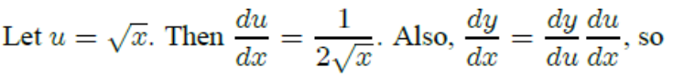
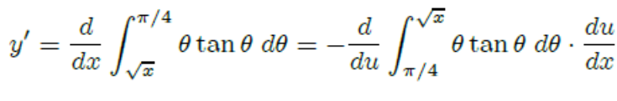
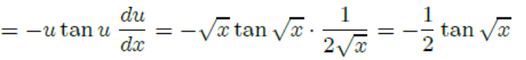

2. Evaluate the integral.
$$\left(a\right)\int_{1}^{8}{x^{-2/3}dx}$$
Solution
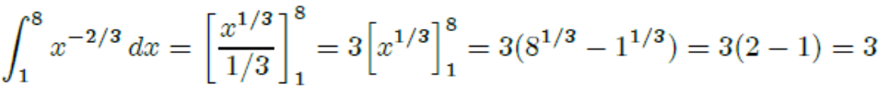
$$\left(b\right)\int_{0}^{1}{(x^{e}+e^{x})dx}$$
Solution
$$\int_{0}^{1}{(x^{e}+e^{x})dx}={\left[\frac{1}{e+1}x^{e+1}+e^{x}\right]}_{0}^{1}=\left(\frac{1}{e+1}1^{e+1}+e^{1}\right)-\left(\frac{1}{e+1}0^{e+1}+e^{0}\right)=\frac{1}{e+1}+e-1$$

$$\left(c\right)\int_{0}^{π}{f(x)dx} where f\left(x\right)=\left\{\begin{aligned}\sin{x}, &if 0≤x<π/2 \\ \cos{x}, &if π/2≤x≤π\end{aligned}\right.$$
Solution
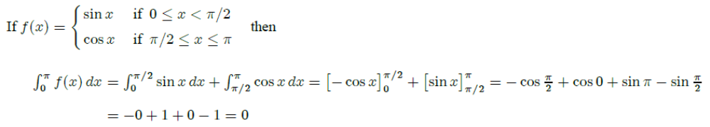

3. Sketch the region enclosed by the given curves and calculate its area.
$$y=\sqrt{x}, y=0, x=4$$
Solution
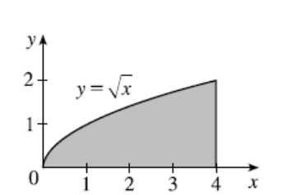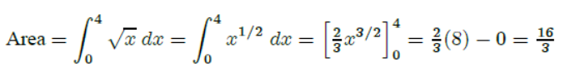

4. Water flows from the bottom of a storage tank at a rate of r(t) = 200 − 4t liters per minute, where 0 ≤ t ≤ 50. Find the amount of water that flows from the tank during the first 10 minutes.
Solution
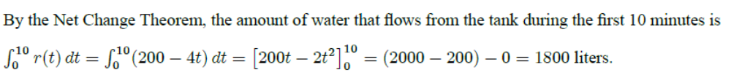

5. (Optional) Verify that $f\left(x\right)=\sin{\sqrt[3]{x}}$ is an odd function and use that fact to show that
$$0≤\int_{-2}^{3}{\sin{\sqrt[3]{x}}dx}≤1$$
Proof:
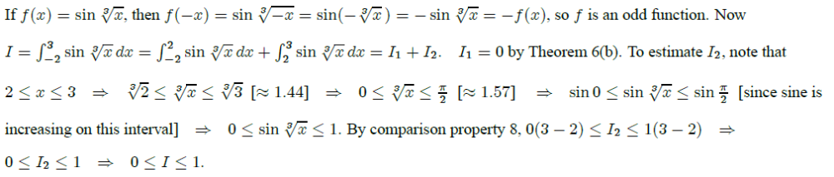

6. If a and b are positive numbers, show that
$$\int_{0}^{1}{x^{a}{(1-x)}^{b}dx}=\int_{0}^{1}{x^{b}{(1-x)}^{a}dx}$$
(Hint: Integration by substitution.)
Proof
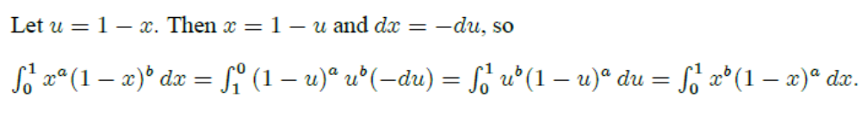
7. If f is continuous and $\int_{0}^{4}{f(x)dx}=10$, find $\int_{0}^{2}{f(2x)dx}$
Solution

8. Evaluate the integrals.
$$(1)\int{\frac{dx}{5-3x}}$$
Solution
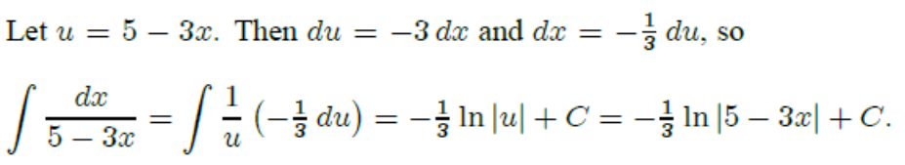

$$(2)\int{\frac{{(\arctan{x})}^{2}}{x^{2}+1}dx}$$
Solution

$$(3)\int{\frac{1+x}{1+x^{2}}dx}$$
Solution
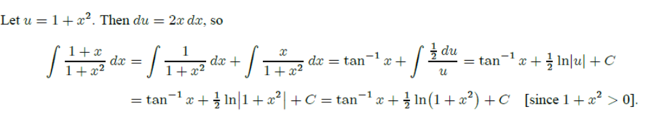

$$(4)\int{\frac{x}{1+x^{4}}dx}$$
Solution

$$(5)\int_{e}^{e^{4}}{\frac{dx}{x\sqrt{\ln{x}}}}$$
Solution
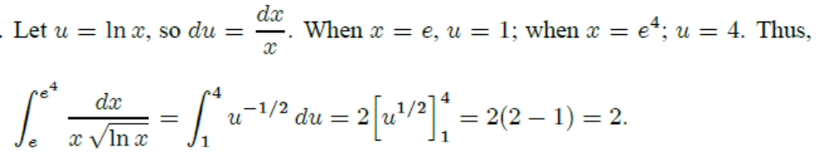

$$(6)\int{\left(x^{2}+2x\right)\cos{x}dx}$$
Solution
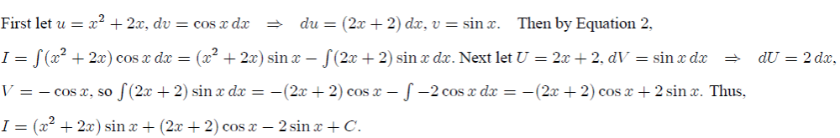

$$(7)\int{\cos^{-1}{x}dx}$$
Solution
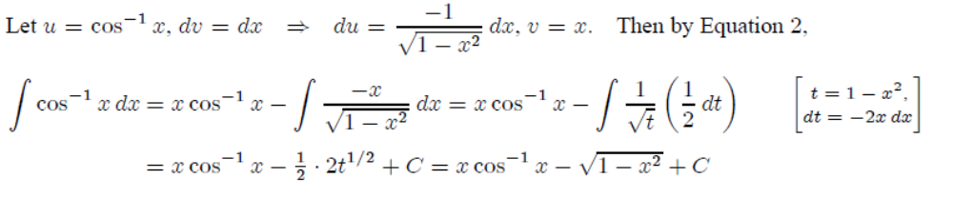

$$(8)\int{{(\ln{x})}^{2}dx}$$
Solution
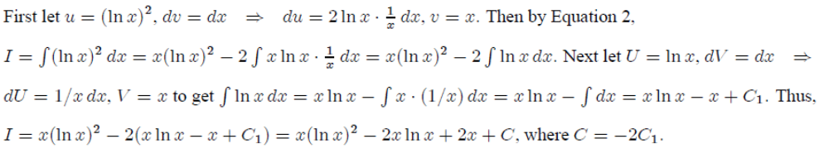

$$(9)\int{e^{2θ}\sin{3θ}dθ}$$
Solution
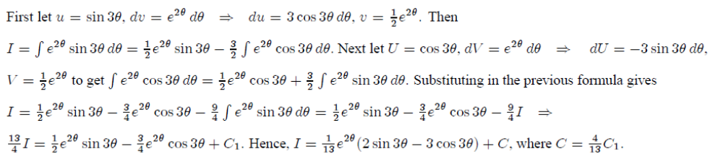

$$(10)\int{\frac{\arcsin{(\ln{x})}}{x}}dx$$
(Hint: First make a substitution and then use integration by parts to evaluate the integral.)
Solution
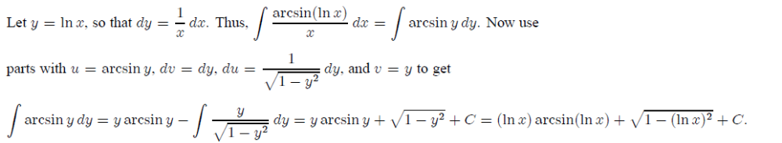

9. (Optional) (a) Use the reduction formula in Example 6 to show that
$$\int_{0}^{π/2}{\sin^{n}x}dx=\frac{n-1}{n}\int_{0}^{π/2}{\sin^{n-2}x}dx$$
where n ≥ 2 is an integer.
(b) Use part (a) to evaluate $\int_{0}^{π/2}{\sin^{3}x}dx$ and $\int_{0}^{π/2}{\sin^{5}x}dx$.
(c) Use part (a) to show that, for odd powers of sine,
$$\int_{0}^{π/2}{\sin^{2n+1}x}dx=\frac{2∙4∙6∙⋯∙2n}{3∙5∙7∙⋯∙(2n+1)}$$
Solution
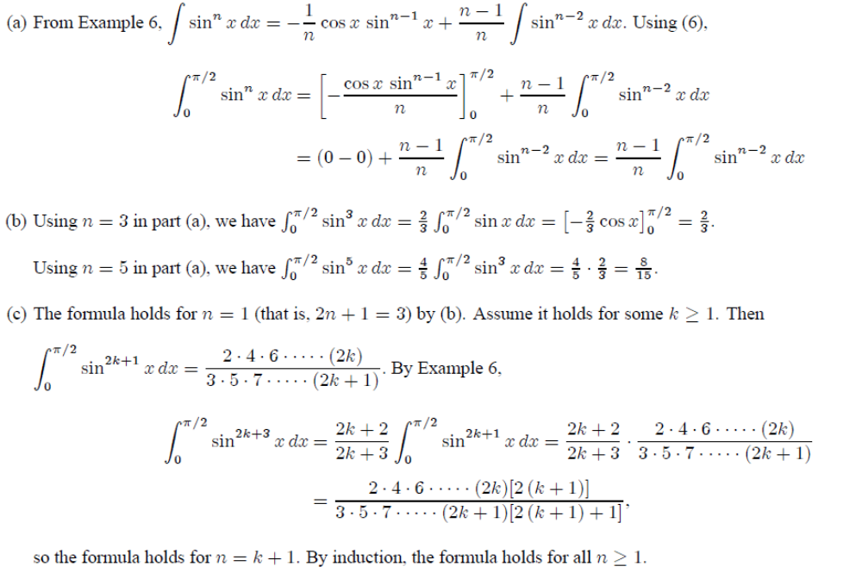

10. (a) Use integration by parts to prove the reduction formula.
$$\int{x^{n}e^{x}dx}=x^{n}e^{x}-n\int{x^{n-1}e^{x}dx}$$
(b) Use part (a) to find $\int{x^{4}e^{x}dx}$.
Proof
(b) By repeated applications of the reduction formula in part (a),
